

PRACTICAL LAB BOOK
MCA 2025-2026 SEM 1
SUBJECT: AI/ML

Submitted By:
Name : Yash Shah
SRN : 31242525
Course : Master of Computer Application
Div : A
Department: Commerce and Management

Guided By
Dr. Supriya Bhosale

Signature

Index Table
Sr. No. | Problem Statement
1 | Python_Diwali_Sales_Analysis – EDA
2 | Training–Testing Data Split
3 | Linear Regression Algorithm
4 | Simple SVM Classification with Visualization
5 | Python Implementation of the K-Nearest Neighbors (KNN) Algorithm
6 | k-Means Clustering Algorithm
7 | Hierarchical Clustering
8 | PCA (Principal Component Analysis)
9 | Confusion Matrix
10 | Accuracy, Precision, Recall, F1 Score Calculations

Practical No 1 : Python_Diwali_Sales_Analysis – EDA

Code:
# import python libraries

import numpy as np
import pandas as pd
import matplotlib.pyplot as plt # visualizing data
%matplotlib inline
import seaborn as sns
# import csv file
df = pd.read_csv('Diwali Sales Data.csv', encoding= 'unicode_escape')
df.shape
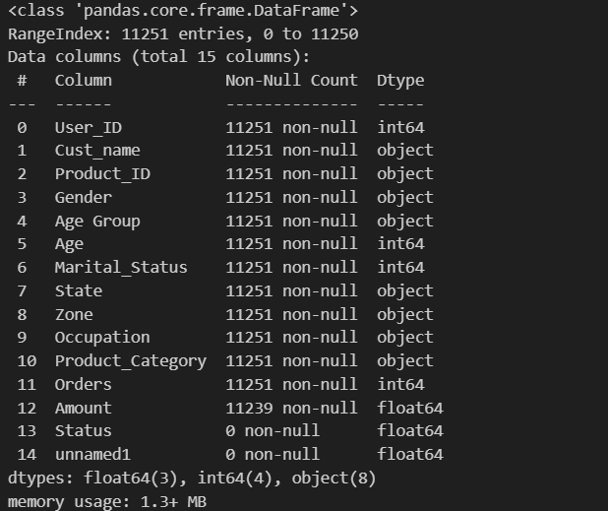
df.head()

#drop unrelated/blank columns
df.drop(['Status', 'unnamed1'], axis=1, inplace=True)

#check for null values
pd.isnull(df).sum()
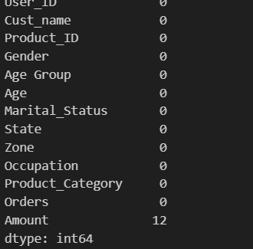

# drop null values
df.dropna(inplace=True)

# change data type
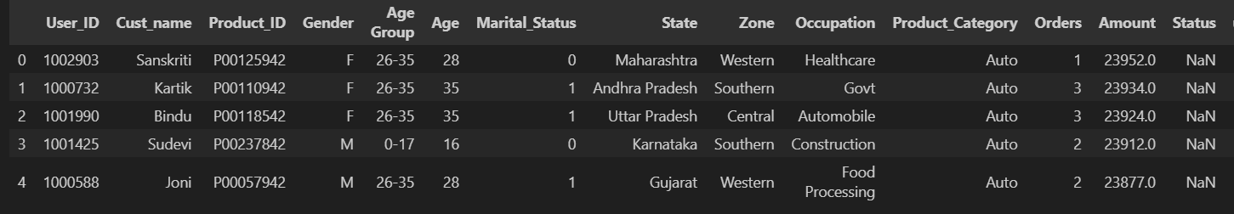
df['Amount'] = df['Amount'].astype('int')
df['Amount'].dtypes
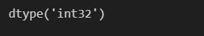
df.columns
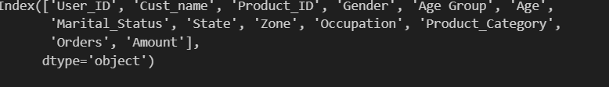
#rename column
df.rename(columns= {'Marital_Status':'Shaadi'})
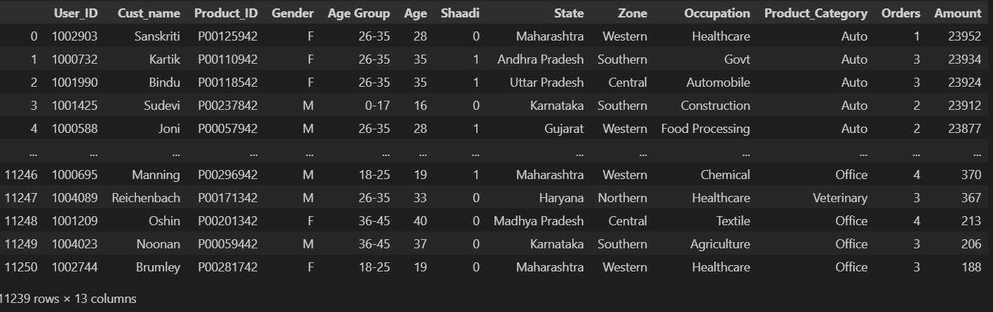
# describe() method returns description of the data in the DataFrame (i.e. count, mean, std, etc)
df.describe()
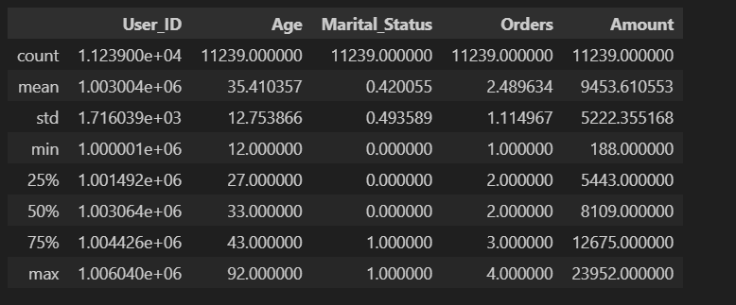
Exploratory Data Analysis
# plotting a bar chart for gender vs total amount

sales_gen = df.groupby(['Gender'], as_index=False)['Amount'].sum().sort_values(by='Amount', ascending=False)

sns.barplot(x = 'Gender',y= 'Amount' ,data = sales_gen)
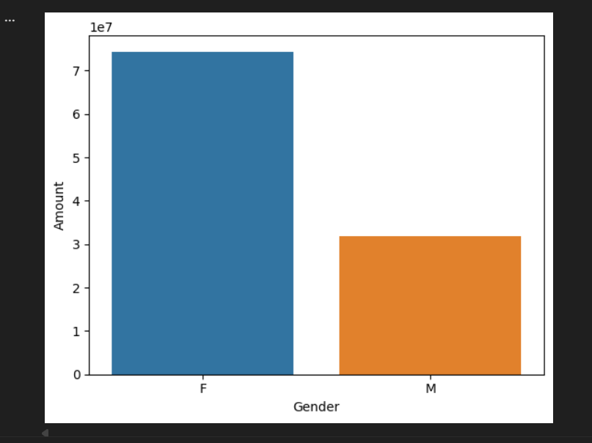

ax = sns.countplot(data = df, x = 'Age Group', hue = 'Gender')

for bars in ax.containers:
ax.bar_label(bars)
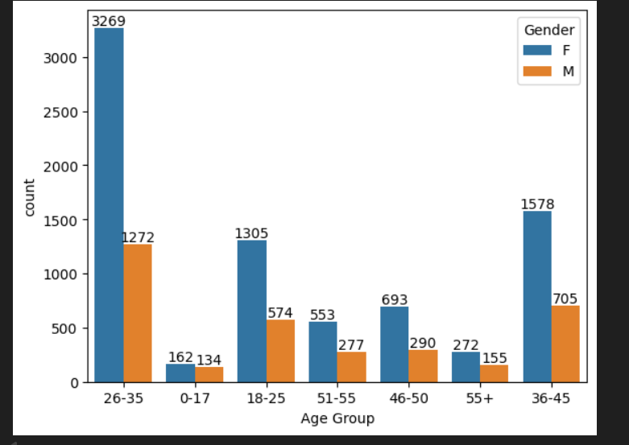

# Total Amount vs Age Group
sales_age = df.groupby(['Age Group'], as_index=False)['Amount'].sum().sort_values(by='Amount', ascending=False)

sns.barplot(x = 'Age Group',y= 'Amount' ,data = sales_age)
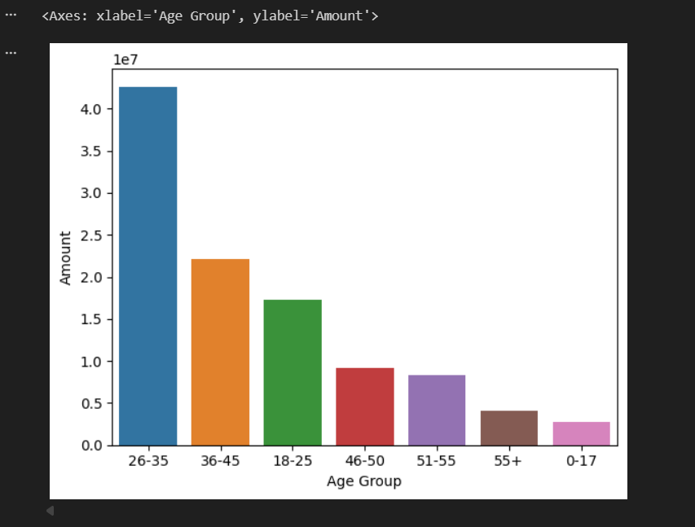

# total number of orders from top 10 states

sales_state = df.groupby(['State'], as_index=False)['Orders'].sum().sort_values(by='Orders', ascending=False).head(10)

sns.set(rc={'figure.figsize':(15,5)})
sns.barplot(data = sales_state, x = 'State',y= 'Orders')

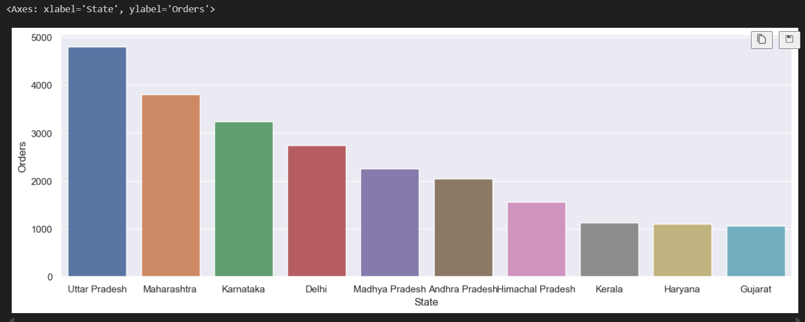

# total amount/sales from top 10 states

sales_state = df.groupby(['State'], as_index=False)['Amount'].sum().sort_values(by='Amount', ascending=False).head(10)

sns.set(rc={'figure.figsize':(15,5)})
sns.barplot(data = sales_state, x = 'State',y= 'Amount')

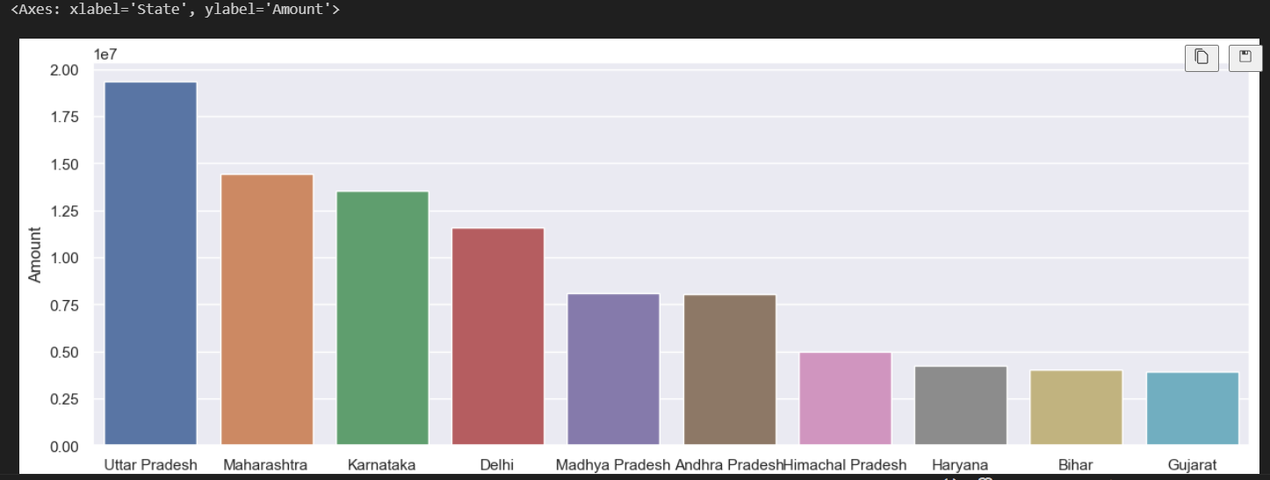

ax = sns.countplot(data = df, x = 'Marital_Status')

sns.set(rc={'figure.figsize':(7,5)})
for bars in ax.containers:
ax.bar_label(bars)

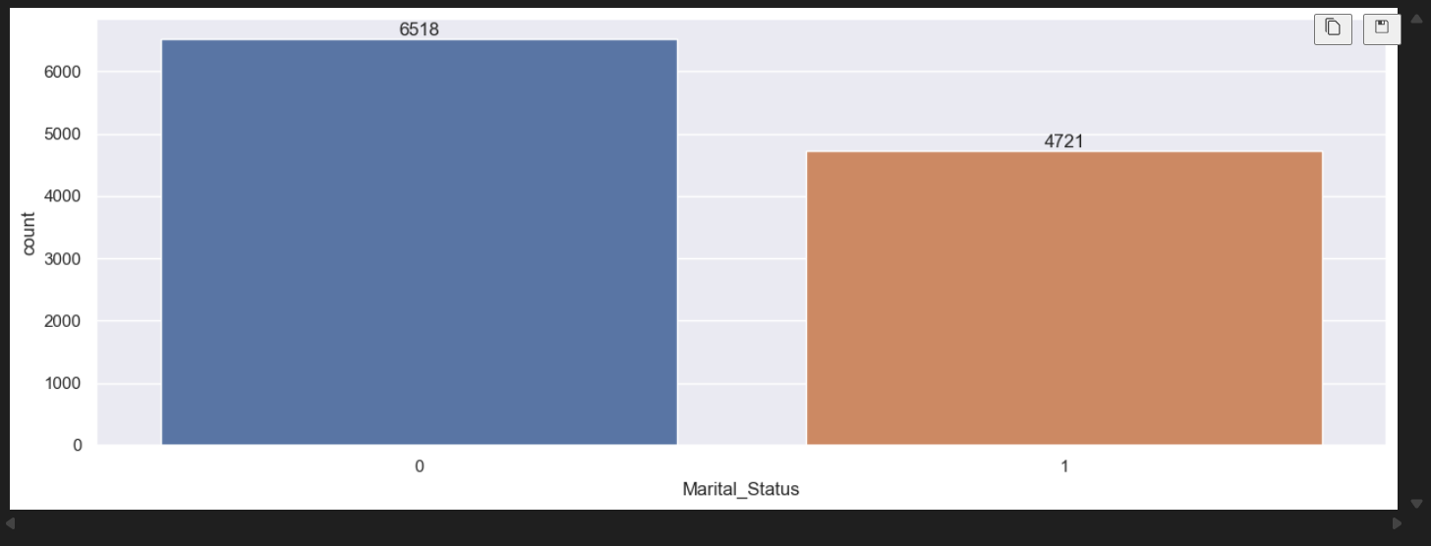

sales_state = df.groupby(['Marital_Status', 'Gender'], as_index=False)['Amount'].sum().sort_values(by='Amount', ascending=False)

sns.set(rc={'figure.figsize':(6,5)})
sns.barplot(data = sales_state, x = 'Marital_Status',y= 'Amount', hue='Gender')

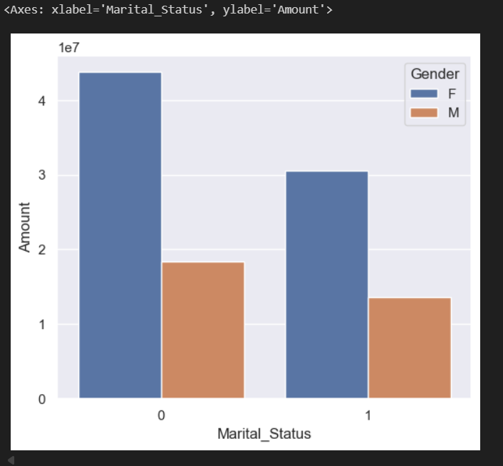
sns.set(rc={'figure.figsize':(20,5)})
ax = sns.countplot(data = df, x = 'Occupation')

for bars in ax.containers:
ax.bar_label(bars)
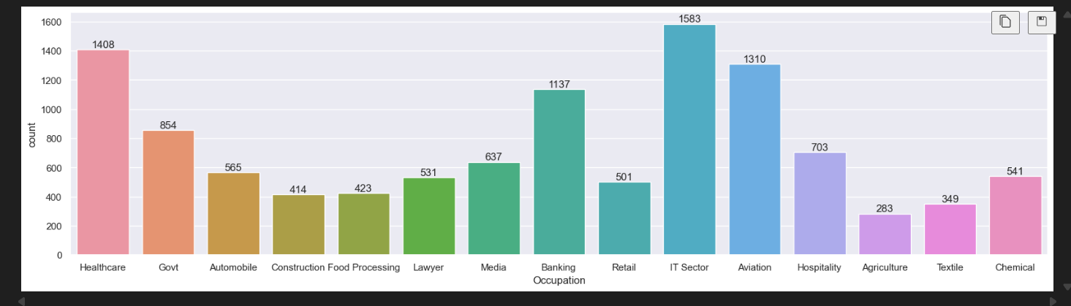

sales_state = df.groupby(['Occupation'], as_index=False)['Amount'].sum().sort_values(by='Amount', ascending=False)

sns.set(rc={'figure.figsize':(20,5)})
sns.barplot(data = sales_state, x = 'Occupation',y= 'Amount')

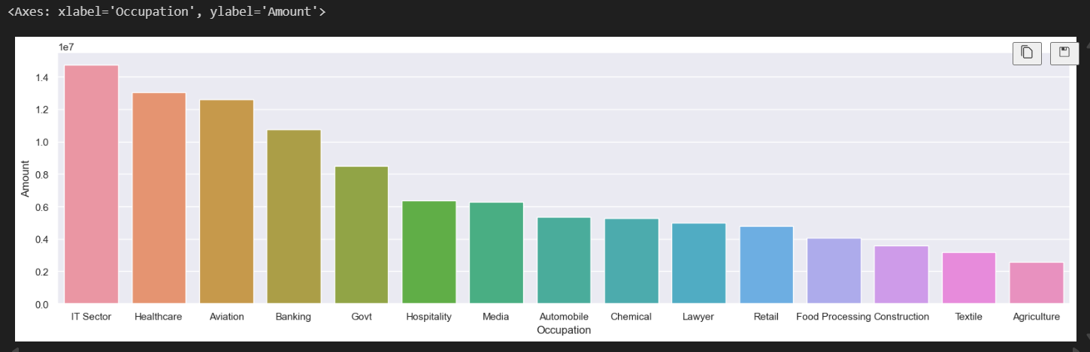

sns.set(rc={'figure.figsize':(20,5)})
ax = sns.countplot(data = df, x = 'Product_Category')

for bars in ax.containers:
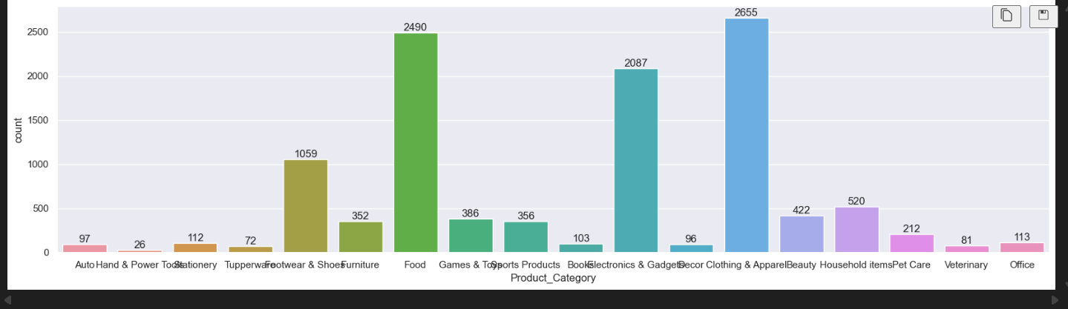
ax.bar_label(bars)

sales_state = df.groupby(['Product_Category'], as_index=False)['Amount'].sum().sort_values(by='Amount', ascending=False).head(10)

sns.set(rc={'figure.figsize':(20,5)})
sns.barplot(data = sales_state, x = 'Product_Category',y= 'Amount')
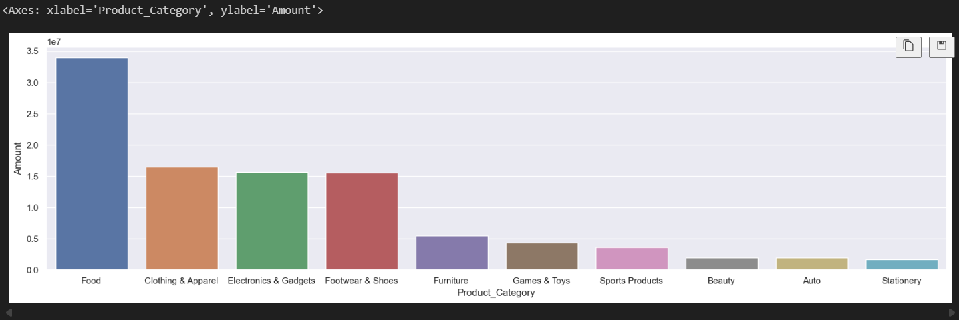

sales_state = df.groupby(['Product_ID'], as_index=False)['Orders'].sum().sort_values(by='Orders', ascending=False).head(10)

sns.set(rc={'figure.figsize':(20,5)})
sns.barplot(data = sales_state, x = 'Product_ID',y= 'Orders')

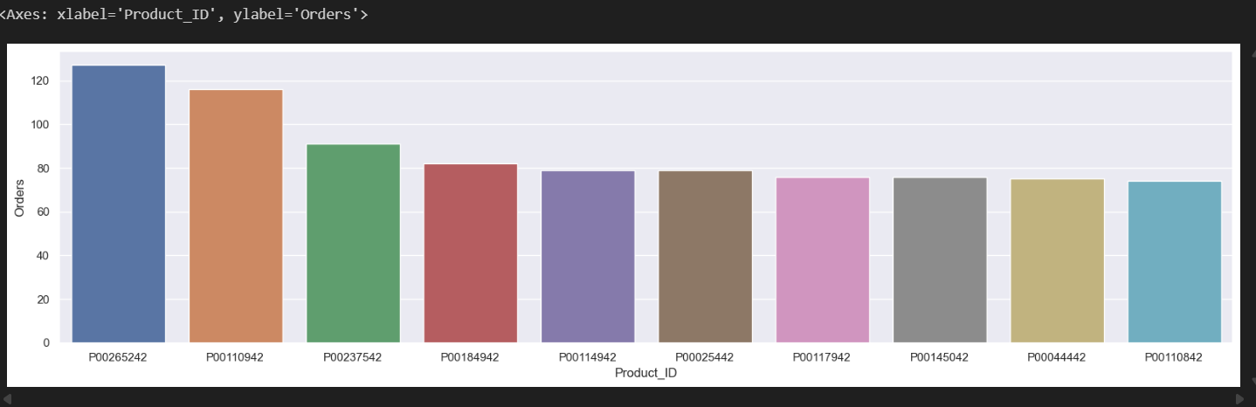

# top 10 most sold products (same thing as above)

fig1, ax1 = plt.subplots(figsize=(12,7))
df.groupby('Product_ID')['Orders'].sum().nlargest(10).sort_values(ascending=False).plot(kind='bar')

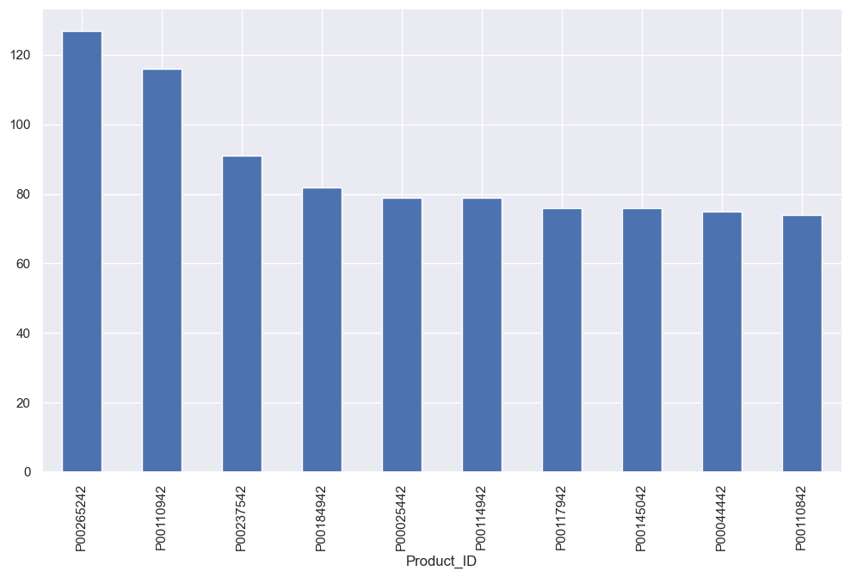

Practical No 2
Training and Testing Data Split

We have a dataset containing prices of used BMW cars. We are going to analyze this dataset and build a prediction function that can predict a price by taking mileage and age of the car as input. We will use sklearn train_test_split method to split training and testing dataset
import pandas as pd
df = pd.read_csv("carprices.csv")
df.head()

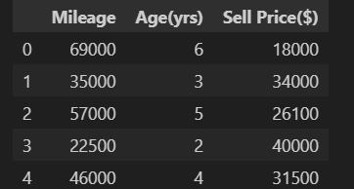

import matplotlib.pyplot as plt
%matplotlib inline

plt.scatter(df['Mileage'],df['Sell Price($)'])
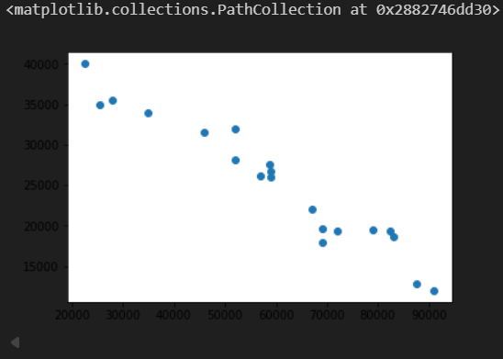

plt.scatter(df['Age(yrs)'],df['Sell Price($)'])

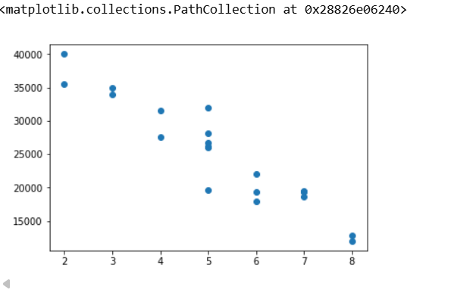

X = df[['Mileage','Age(yrs)']]

y = df['Sell Price($)']

from sklearn.model_selection import train_test_split
X_train, X_test, y_train, y_test = train_test_split(X,y,test_size=0.3)

X_train
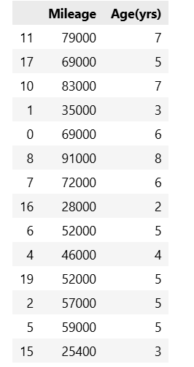

X_test

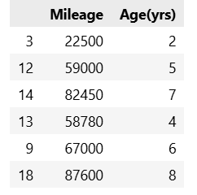

y_train

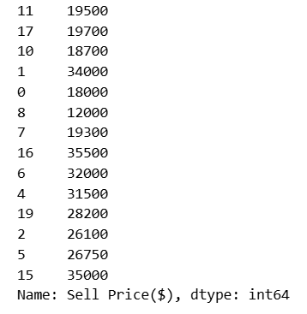
y_test

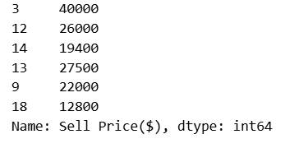

from sklearn.linear_model import LinearRegression
clf = LinearRegression()
clf.fit(X_train, y_train)

clf.predict(X_test)

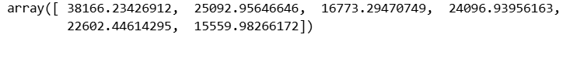

clf.score(X_test, y_test)

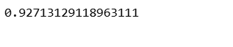
X_train, X_test, y_train, y_test = train_test_split(X,y,test_size=0.3,random_state=10)
X_test
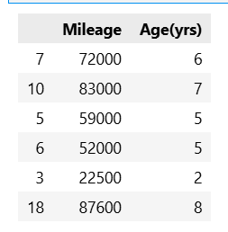

Practical No 3
Simple SVM Classification with Visualization
from sklearn import datasets
from sklearn.svm import SVC
import matplotlib.pyplot as plt

# Load dataset (first 2 features for easy plotting)
iris = datasets.load_iris()
X = iris.data[:, :2]
y = iris.target

# Train SVM
model = SVC(kernel='linear')
model.fit(X, y)

# Basic plot
plt.scatter(X[:, 0], X[:, 1], c=y)
plt.xlabel('Sepal length')
plt.ylabel('Sepal width')
plt.title('SVM - Iris Data (Basic Plot)')
plt.show()
Output:

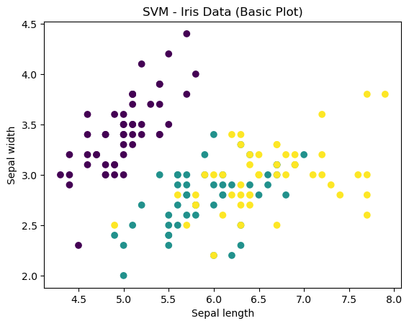

Practical No 4
Linear Regression Algorithm:
import numpy as np
import pandas as pd
import matplotlib.pyplot as plt
from sklearn.linear_model import LinearRegression
from sklearn.model_selection import train_test_split
from sklearn.metrics import mean_squared_error, r2_score

(Using sample data for simplicity)
# Sample dataset
data = {
'Experience': [1, 2, 3, 4, 5, 6, 7, 8, 9, 10],
'Salary': [30000, 35000, 40000, 45000, 50000, 55000, 60000, 65000, 70000, 75000]
}
df = pd.DataFrame(data)
print(df.head())

X = df[['Experience']] # Independent variable
y = df['Salary'] # Dependent variable

X_train, X_test, y_train, y_test = train_test_split(X, y, test_size=0.2, random_state=42)

model = LinearRegression()
model.fit(X_train, y_train)

y_pred = model.predict(X_test)

print("Mean Squared Error:", mean_squared_error(y_test, y_pred))
print("R^2 Score:", r2_score(y_test, y_pred))

plt.scatter(X, y, color='blue', label='Actual')
plt.plot(X, model.predict(X), color='red', linewidth=2, label='Prediction')
plt.xlabel('Years of Experience')
plt.ylabel('Salary')
plt.title('Linear Regression Example')
plt.legend()
plt.show()

Output:
Experience Salary
0 1 30000
1 2 35000
2 3 40000
3 4 45000
4 5 50000
Mean Squared Error: 0.0
R^2 Score: 1.0

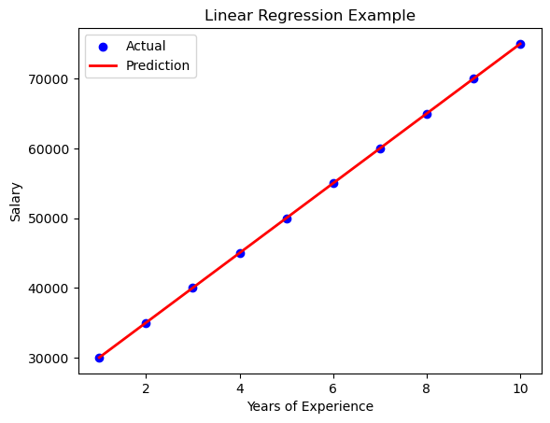

Practical No 5
Python implementation of the K-Nearest Neighbors (KNN) algorithm
# Import required libraries
from sklearn.datasets import load_iris
from sklearn.neighbors import KNeighborsClassifier
from sklearn.model_selection import train_test_split
from sklearn.metrics import accuracy_score

# Load the Iris dataset
iris = load_iris()
X = iris.data[:, :2] # Only use first 2 features for simplicity
y = iris.target

# Split into training and testing data (70% train, 30% test)
X_train, X_test, y_train, y_test = train_test_split(X, y, test_size=0.3, random_state=0)

# Create KNN classifier with k=3
knn = KNeighborsClassifier(n_neighbors=3)

# Train the model
knn.fit(X_train, y_train)

# Predict
y_pred = knn.predict(X_test)

# Accuracy
print("Accuracy:", accuracy_score(y_test, y_pred))
print("Predicted:", y_pred)
print("Actual: ", y_test)
Output:
Accuracy: 0.7333333333333333
Predicted: [1 1 0 2 0 2 0 1 1 2 2 2 2 2 2 0 2 1 0 0 1 1 0 0 2 0 0 2 1 0 2 1 0 2 2 0 0
1 2 1 1 0 2 0 0]
Actual: [2 1 0 2 0 2 0 1 1 1 2 1 1 1 1 0 1 1 0 0 2 1 0 0 2 0 0 1 1 0 2 1 0 2 2 1 0
1 1 1 2 0 2 0 0]
Practical No 6
k-Means Clustering Algorithm:
import matplotlib.pyplot as plt
from sklearn.cluster import KMeans
from sklearn.datasets import make_blobs

X, y_true = make_blobs(n_samples=300, centers=3, cluster_std=0.60, random_state=0)

plt.scatter(X[:, 0], X[:, 1], s=50)
plt.title("Original Data Points")
plt.show()

kmeans = KMeans(n_clusters=3)
kmeans.fit(X)
y_kmeans = kmeans.predict(X)

plt.scatter(X[:, 0], X[:, 1], c=y_kmeans, s=50)

centers = kmeans.cluster_centers_
plt.scatter(centers[:, 0], centers[:, 1], c='red', s=50, marker='X')
plt.title("k-Means Clustering Output")
plt.show()
Output:

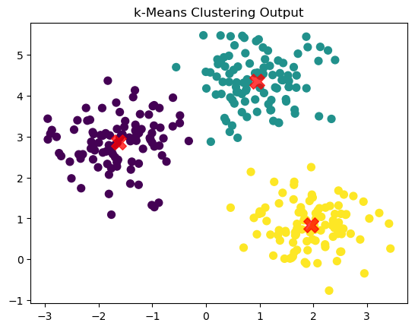
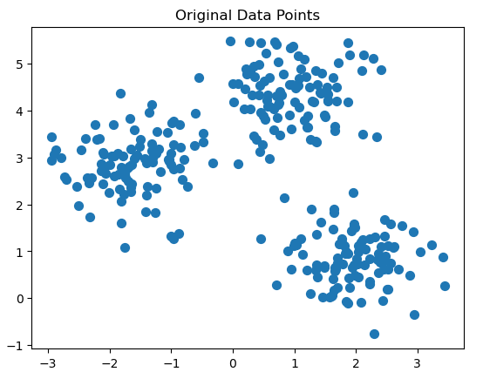

Practical No 7
Write a program for Hierarchical Clustering on Customers Dataset.

import pandas as pd
import matplotlib.pyplot as plt
from scipy.cluster.hierarchy import dendrogram, linkage
from sklearn.cluster import AgglomerativeClustering

# Load dataset
df = pd.read_csv("C:/Mall_Customers.csv")

# Select Annual Income & Spending Score
X = df.iloc[:, [3, 4]].values

# Step 1: Draw dendrogram
plt.figure(figsize=(8,5))
dendrogram(linkage(X, method='ward'))
plt.title("Dendrogram")
plt.xlabel("Customers")
plt.ylabel("Distance")
plt.show()

# Fit hierarchical clustering with 5 clusters
hc = AgglomerativeClustering(n_clusters=5, metric='euclidean', linkage='ward')
y_hc = hc.fit_predict(X)

# Visualize clusters
plt.scatter(X[y_hc == 0, 0], X[y_hc == 0, 1], c='blue', label='Cluster 1')
plt.scatter(X[y_hc == 1, 0], X[y_hc == 1, 1], c='red', label='Cluster 2')
plt.scatter(X[y_hc == 2, 0], X[y_hc == 2, 1], c='green', label='Cluster 3')
plt.scatter(X[y_hc == 3, 0], X[y_hc == 3, 1], c='orange', label='Cluster 4')
plt.scatter(X[y_hc == 4, 0], X[y_hc == 4, 1], c='purple', label='Cluster 5')

plt.title("Customer Segments (Hierarchical Clustering)")
plt.xlabel("Annual Income (k$)")
plt.ylabel("Spending Score (1-100)")
plt.legend()
plt.show()

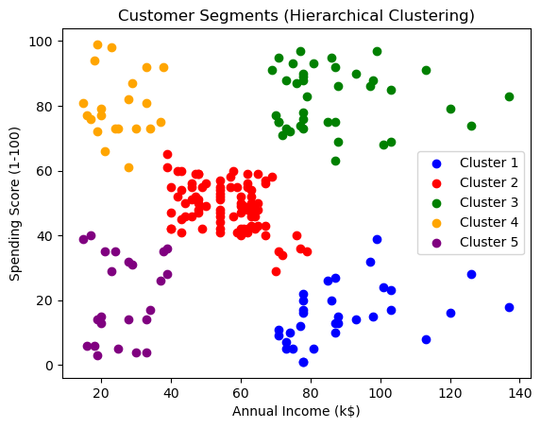
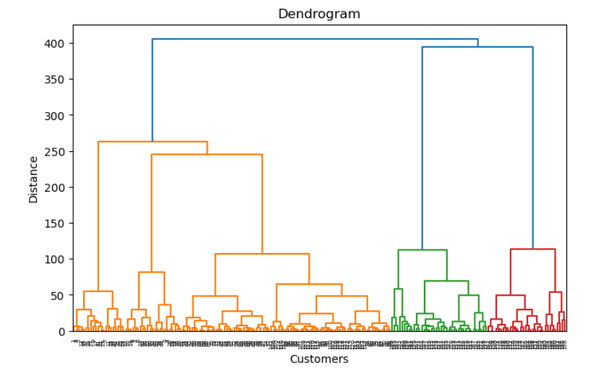

Practical No 8

Write a program for using PCA on MNIST Dataset.
import pandas as pd
import numpy as np
import matplotlib.pyplot as plt
%matplotlib inline
from sklearn.datasets import load_digits
from sklearn.ensemble import RandomForestClassifier
from sklearn.metrics import accuracy_score,classification_report
from sklearn.model_selection import train_test_split
from sklearn.decomposition import PCA
import warnings
warnings.filterwarnings('ignore')
data = load_digits()
digits = pd.DataFrame(data.data)
target = pd.DataFrame(data.target)
digits.head()
print(digits.shape)
plt.imshow(digits.iloc[1].values.reshape(8,8),cmap='gray')
x_train,x_test,y_train,y_test = train_test_split(digits,target,test_size=0.2,random_state = 42)
random = RandomForestClassifier(n_estimators = 100,max_depth=10,min_samples_split=0.2)
random.fit(x_train,y_train)
predict = random.predict(x_test)
print('Accuracy Score for Random Forest Classification without PCA is {}'.format(accuracy_score(y_test,predict)))
print(classification_report(y_test,predict))
pca = PCA(0.95) #PCA(5)
x = pca.fit_transform(digits)
x.shape
x_train,x_test,y_train,y_test = train_test_split(x,target,test_size = 0.2,random_state = 42)
random = RandomForestClassifier(n_estimators = 100,max_depth=10,min_samples_split=0.2)
random.fit(x_train,y_train)
predict = random.predict(x_test)
print('Accuracy Score for Random Forest Classification after PCA is {}'.format(accuracy_score(y_test,predict)))
print(classification_report(y_test,predict))
pca.components_[0]
len(pca.components_)
pca.explained_variance_ratio_
plt.imshow(pca.components_[0].reshape(8,8),cmap='gray')
Output
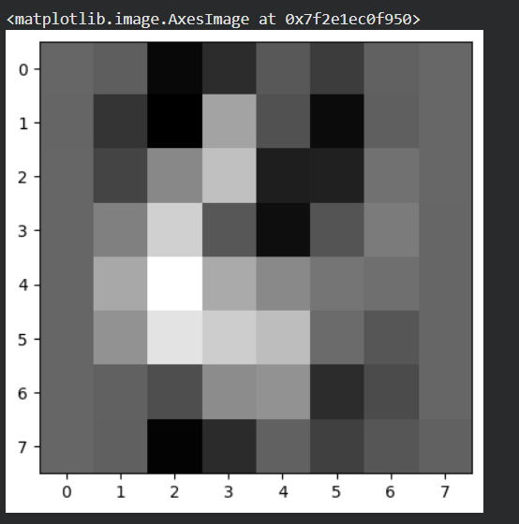
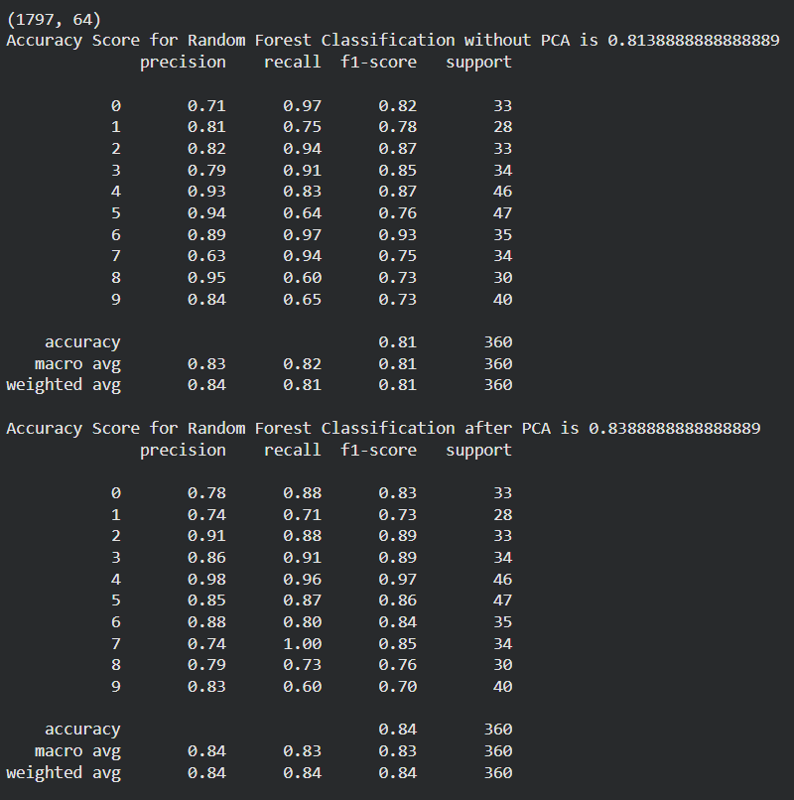

Practical No 9
Confusion Matrix
# Import required libraries
from sklearn.metrics import confusion_matrix, ConfusionMatrixDisplay
import matplotlib.pyplot as plt

# Step 1: Define actual (true) and predicted labels
y_true = [0, 1, 1, 1, 0, 1, 0, 0, 1, 0] # Actual values
y_pred = [0, 1, 0, 1, 0, 1, 0, 1, 1, 0] # Predicted values

# Step 2: Compute the confusion matrix
cm = confusion_matrix(y_true, y_pred)

# Step 3: Print numeric confusion matrix
print("Confusion Matrix (numeric form):")
print(cm)

# Step 4: Plot a labeled confusion matrix (diagram)
disp = ConfusionMatrixDisplay(confusion_matrix=cm,
display_labels=["Class 0", "Class 1"])
disp.plot(cmap=plt.cm.Oranges) # You can try Blues, Greens, Purples, etc.
plt.title("Confusion Matrix Visualization")
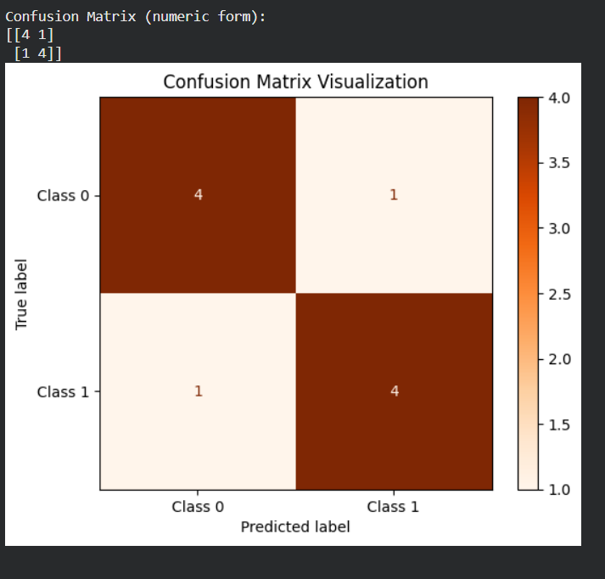
plt.show()

Practical No 10
Accuracy, Precision, Recall, F1 Score calculations:
# Import necessary libraries
from sklearn.metrics import accuracy_score, precision_score, recall_score, f1_score
# Sample ground truth (actual values)
y_true = [0, 1, 1, 1, 0, 1, 0, 0, 1, 0]
# Sample model predictions
y_pred = [0, 1, 0, 1, 0, 1, 0, 1, 1, 0]
# Accuracy
accuracy = accuracy_score(y_true, y_pred)
# Precision
precision = precision_score(y_true, y_pred)
# Recall
recall = recall_score(y_true, y_pred)
# F1 Score
f1 = f1_score(y_true, y_pred)
# Display the results
print("Accuracy:", accuracy)
print("Precision:", precision)
print("Recall:", recall)
print("F1 Score:", f1)

